The “Leave a Legacy” tile project offers a unique opportunity to show your support for the school while making your memories a lasting part of the Performing Arts Center at Vista Murrieta High School.  A personalized, commemorative tile will become part of the front of the building, and your donation will help to build the school’s legacy by supporting the Visual, Performing and Fine Arts programs at Vista Murrieta High School. **These commemorative “Leave a Legacy” tiles are only $50 and not only support meaningful programs but also can be a great gift to you (or your student):**

* Commemorate your graduation *Celebrate Outstanding Achievements
* Memorialize a friend, family member, or faculty member *Honor a graduate

To purchase a Legacy tile, please fill out the form below and take to **bookkeeper with payment (or purchase on our school’s webstore), by March 29, 2025**. Tiles will be installed during summer after order has been made and will be displayed for years to come! Orders received AFTER March 29 will still be installed, but at a future date, as this is an on-going endeavor.

**Step One**: Name to be displayed: __________________________________

**Step Two**: Select one of the programs below that you were a part of / want to support.

_____Theatre ____Band _____  Choir

_____ Dance _____  Fine Art _____  General

____ 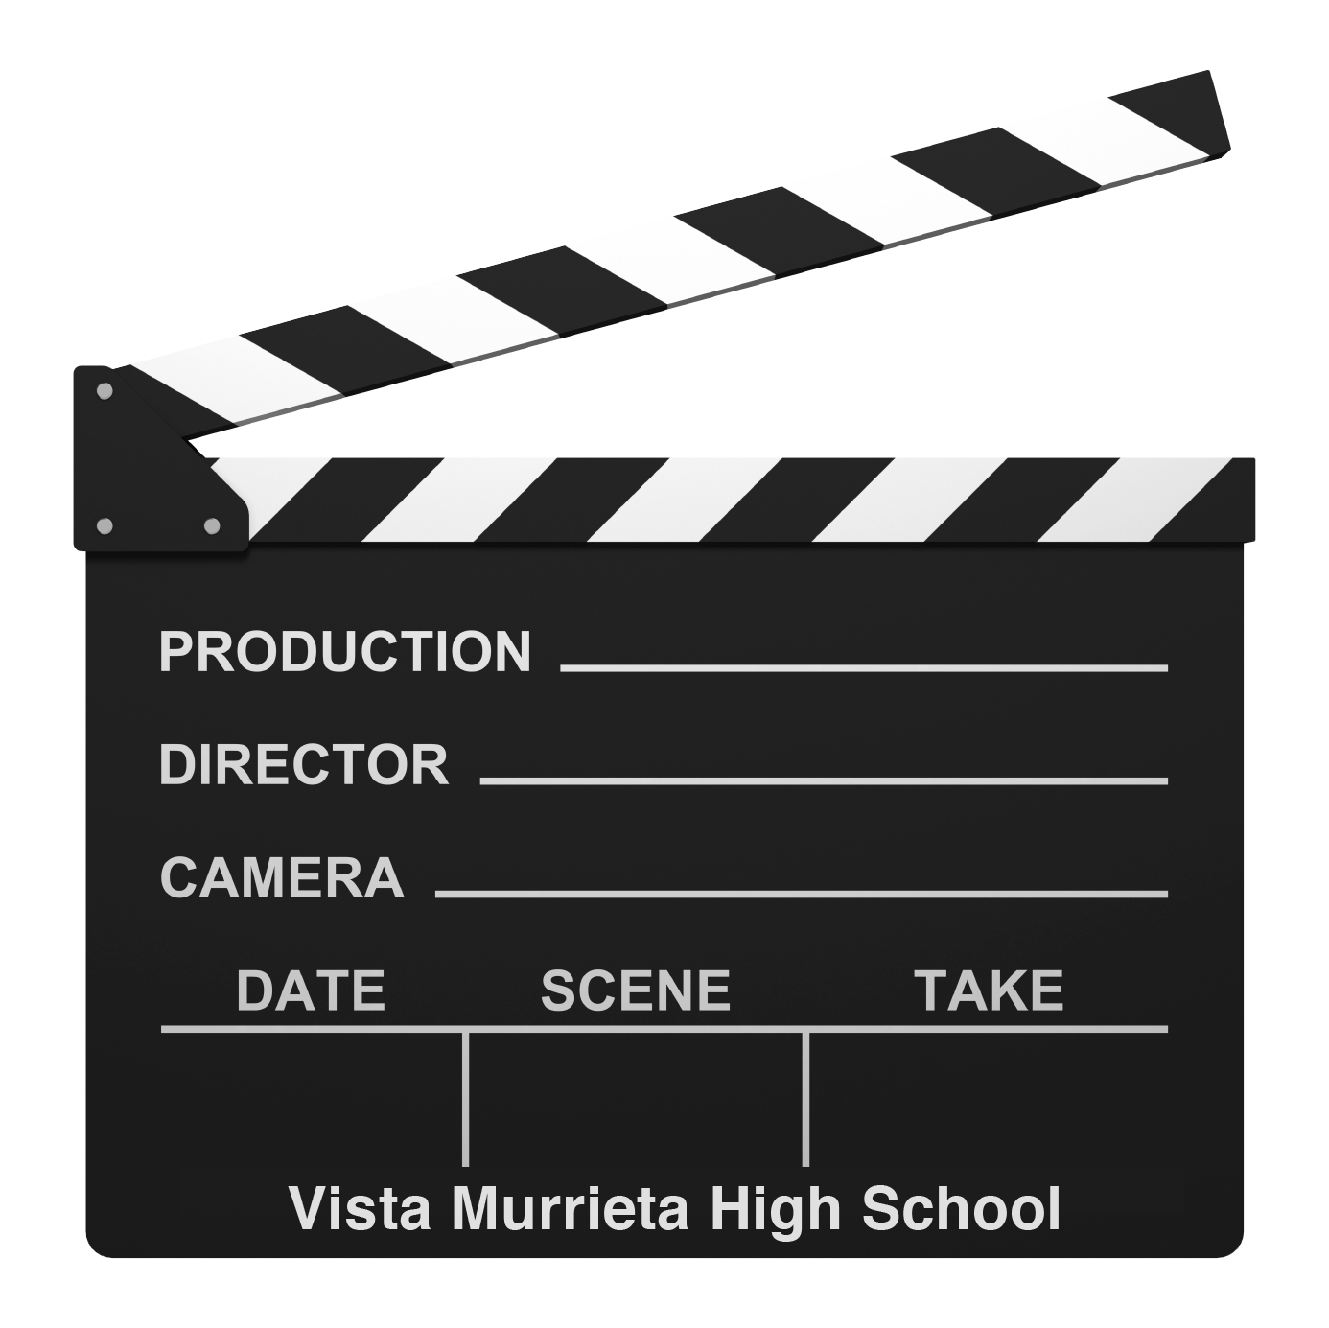TV / Video ____  Graphic Design

**Step Three**: Include the year: _____________________

**Step Four**: Submit this form, with payment to our bookkeeper (by March 29, 2025).

**Step Five**: Come back to see your Legacy for years to come on our Performing Arts Center.

Thank you for supporting the Arts at Vista Murrieta High School.